

**IŞIK UNIVERSITY**

**Faculty of Economics, Administrative and Social Sciences**

**Department of Information Technologies**

***B. S. Thesis***

Examining and Analyzing World Suicide Cases from Different Perspectives

Zeynep Diğde Aydı

217MI1189

**Supervised by:** Assist. Prof. Dr. Şahin Aydın

**JANUARY-2022**

**Examining and Analyzing World Suicide Cases from Different Perspectives**

A Project Presented  
by

**Zeynep Diğde Aydı**

**217MI1189**

to  
The Department of Information Technologies

in partial fulfillment of the requirements  
for the degree of

**Bachelor of Science**

in the field of  
Management Information Systems

Işık University  
İstanbul, Turkey

JANUARY-2022

© Copyright [2022] by [Zeynep Diğde Aydı]

All Rights Reserved

### Abstract

Suicide has become one of the most important issues that psychiatrists and psychologists deal with, especially in our century. In the last 45 years, the world suicide rate has increased by 60% and suicide deaths are expected to reach 1.6 million by 2022.

In my project, I used various factors such as age, gender, and geographic region to find out what had a major impact on the suicide rate.To compare different factors, I aimed to draw meaningful conclusions by visualizing whether the correlation was weak or strong, with graphs and various Python codes.

My focus was on whether suicide was affected by age, gender, place of residence, or the country's monetary status (GDP). I hope this study will help suicide prevention strategies for countries.

### Acknowledgements

I would like to thank my advisors Assist. Prof. Dr. Şahin Aydın and Assist. Prof. Dr. Gülsüm Çiğdem Çavdaroğlu who did not spare their support during the execution of this study and showed patience during my studies also, my friends who were by my side at every moment and did not hesitate to give their help.

Zeynep Diğde Aydı

January-2022

### Contents

Abstract 2

Acknowledgements 3

Contents 4

List of Figures 6

Chapter 1 Introduction 8

1.1 Overview 8

1.2 Contributions 9

1.3 Research Question 10

1.4 Outline of the Project 10

Chapter 2 Literature Review 12

2.1 Overview 12

2.2 Is there a significant difference in suicide rates between age groups? 12

2.3 Is there a significant difference in suicide rates between sex groups? 13

2.4 “Preventing suicide: a global imperative” 13

Chapter 3 Research, Program Used 14

3.1 Python Programming Language 14

Chapter 4 Data Analysis 15

4.1 Data Cleaning 15

4.1.1 Data Collecting 16

4.2 Exploratory Data Analysis (EDA) 18

4.2.1 Suicide Charts and Forecasts of Countries 18

4.2.2 Who is more suicidal: Youth, Adults, or Old? 24

4.2.3 Suicide Rates of Age Range by Continents 24

4.2.4 Relationship Between Sex and Age Range and Suicide 28

4.2.5 Does GDP Per Capita Have an Effect on Suicide? 36

4.2.6 Generation and Suicide 38

Chapter 5 Implementation of Project 40

5.1 Overview 40

Chapter 6 Results and Discussion 42

6.1 Results 42

6.2 Discussion 44

Chapter 7 Conclusion 45

References 46

### List of Figures

Figure 1 - WHO Worldwide Suicide Rates in 2016 (Per Hundred Thousand)……….……….9

Figure 2 - Detecting missing data…………………………………………..…………….…..15

Figure 3 - Continental distribution of suicides……………………………..……………..….16

Figure 4 - Suicide rate between 1985 and 2015 …………………………..…….……………17

Figure 5 – Numerical distribution of continental suicides …………….……..………………18

Figure 6 – Turkey's Suicide Prediction Chart ………………………………….…………….19

Figure 7 – Greece’ Suicide Prediction Chart ……………………………….…….………….19

Figure 8 – Belgium’s Suicide Prediction Chart ….……………………..……….……..…….20

Figure 9 – Bulgaria’s Suicide Prediction Chart ……………………………..……………….20

Figure 10 – Brazil’s Suicide Prediction Chart ………………………………...……………..21

Figure 11 – Canada’s Suicide Prediction Chart ………………………….…………………..22

Figure 12 – Cuba’s Suicide Prediction Chart …………………...….….………………..……22

Figure 13 – Australia’s Suicide Prediction Chart ………………………......………………..23

Figure 14 - Suicide rates by generation groups …………………………..……………..……24

Figure 15-Suicide per Age/Suicide_No ……………………………………..……………….25

Figure 16- Bar Graph showing the number of suicides of people in different age groups-Asia ………………………………………………………………………………………….…….25

Figure 17 – Bar Graph showing the number of suicides of people in different age groups-North America ……………………………………………………….…………………..….26

Figure 18– Bar Graph showing the number of suicides of people in different age groups-Australia Oceania …………………………………………………………………………….27

Figure 19 - Bar Graph showing the number of suicides of people in different age groups-Europe …….28

Figure 20 – Relationship between suicide by gender and age groups ……...………………..29

Figure 21 - Suicide rate by gender and age groups-North America …………………………30

Figure 22- Suicide rate by gender and age groups-Europe ……………………………..……31

Figure 23 - Suicide rate by gender and age groups-South America………...………………..32

Figure 24 - Suicide rate by gender and age groups-Africa ……………………………..……33

Figure 25 - Suicide rate by gender and age groups-Australia Oceania……………………….34

Figure 26 - The effect of gender and age on suicide rates ………………………...……..…..35

Figure 27 - Suicide rates of countries with different GDP in the world………………..……36

Figure 28- The correlation between different columns……………………………………….37

### Introduction

##### Overview

Approximately 800,000 people commit, or attempt suicide each year. Every suicide is a condition with serious implications, affecting communities and countries. Suicide is a serious public health problem. But suicides can be prevented with timely, often low-cost interventions. For interventions to be effective, countries need comprehensive and multisectoral suicide prevention strategies.

Suicide can be prevented. There are a number of measures that can be taken at the population, population and individual level to prevent suicide and suicide attempts. The WHO approach to suicide prevention "LIVE LIFE" recommends evidence-based interventions.

* Engaging with the media to report suicide responsibly.
* Developing socio-emotional life skills
* Early identification, assessment, and follow-up of anyone affected by suicidal behavior.
* These should go hand in hand with situational analysis, multi-sectoral collaboration, awareness raising, perception building, oversight, monitoring and evaluation.

No single approach can have an impact on a subject as complex as suicide. Globally, only 100 Member States have registry data that can be directly used to estimate suicide rates. Under-reporting is likely to be a bigger problem for suicide than many other causes.

WHO recognizes suicide as a public health priority? The first WHO World Suicide Report, published in 2014, called it "Preventing suicide: a global imperative". It aims to raise awareness of the public health importance of suicide and to make suicide prevention a high priority on the global public health agenda.

harita içeren bir resim

Açıklama otomatik olarak oluşturuldu

Figure 1 - WHO Worldwide Suicide Rates in 2016 (Per Hundred Thousand)

##### Contributions

After the knowledge that suicide is a global problem and approximately 800,000 people die every year, I decided to raise awareness by working on this issue. I want to analyze suicide data and find out which factors are most likely to cause suicide.

In my project, I used various factors such as age, gender and geographic region, generation to find out what had a major impact on the suicide rate. To compare different factors, to find out whether the correlation is strong or weak, I used graphs and made interpretive conclusions.

The results I hope to find;

* Are younger individuals more prone to suicide?
* Do men commit suicide more than women?
* Suicide increases with age
* Suicide is less in countries with high GDP?
* Does generation difference affect suicide?

## 1.3 Research Question

* What is the percentage of men and women suicide globally?
* What is the distribution of suicides among the different age groups?
* What is the suicide rates among the different generations?
* Looking at Suicides trends overs years

##### Outline of the Project

Data visualization techniques aim to present us as concrete information and thus enable us to make inferences, that is, each user can interpret the data according to his/her own purpose and make different inferences.

**Data Description**

The dataset provides information on suicide rates worldwide. This data set includes suicide information for the years 1985 and 2016. There are about 27,000 data from 100 countries. Suicide rates dataset includes country, year, gender, age, suicide_no, population, country-year, HDI for year, gdp_for_year, gdp_per_capita and generation.

Dimensions:

* Age – Age range of the population from 5 years to 75+ years.
* Country – 100 countries
* Country-Year – Essentially a combination of country and year
* GDP for year – GDP of the country based on year ($ value)
* Generation – A set of 6 generations based on factual representation of age(1. (G.I. Generation): 1901-1927, 2.Silent Generation: 1928-1945, 3.Boomers: 1946 – 1964, 4.Generation X: 1965 – 1980, 5.Millennials (Generation Y): 1981 – 1996, 6.Generation Z: 1997 – 2010)
* Sex – Male and female
* Year – Year from 1985 to 2016
* GDP per capita – GDP of relative country as per population
* HDI for year – Human development index for the relative year
* Population – total population of relative country
* Suicides no – No of suicides
* Suicides/100K Pop – No of suicides per 100,000 people in the relative country

**Null values:**

HDI for year – Most of these values are null and we will not be using these values in our visualizations.

**Data clean:**

The dataset contained missing values for the HDI dimension for "Year. Since these missing values are approximately 70% of the records for this variable, we excluded the dimension from our analysis.

I wanted to investigate possible causes that may increase the risk of suicide in populations by using different data analysis methods.

### Literature Review

##### Overview

Suicide is a serious problem in all societies to varying degrees, but the lower or higher effect in some parts of the world may provide clues as to the causes of suicides.

A large percentage of total suicides from low- and middle-income countries appear to be due to a larger population living in these countries, as high-income countries account for 23.9% of global suicides.

##### Is there a significant difference in suicide rates between age groups?

Suicide: Self-intentional killing is one of the leading causes of death worldwide.

It is important to monitor suicide rates among age groups. Findings based on identifying risky groups among women and men, predicting suicide and taking precautions have an important role in developing policies to prevent more suicides [4,2].

Teens are by nature vulnerable to mental health issues, especially during their teenage years. In recent years, interviews with key sources of information and review of records have revealed important information about risk factors for youth, including follow-up studies of suicide attempters. It is very important to identify the different types of factors that are clearly associated with an increased risk of teen suicide [3].

##### Is there a significant difference in suicide rates between sex groups?

There are also differences in the sex ratio according to age. There are many possible reasons for the different suicide rates in men and women: gender equality issues, differences in the socially acceptable ways for men and women to cope with stress and conflict. Availability and preference of different means of suicide, availability and patterns of alcohol consumption, and differences in the rates of seeking care for mental disorders between men and women cause these rates to vary. The very wide range in sex ratios for suicide suggests that the relative importance of these different causes varies widely by country and region[5].

##### “Preventing suicide: a global imperative”

800.000 people commit suicide each year, and there are many more who attempt suicide. Every suicide is a tragedy that affects families, communities and entire countries, with long-lasting effects on the people left behind. As mental health awareness grows, there is more public understanding of potential contributing factors. One of the questions that remains, though, is about this gender gap. This rate seems particularly large given that women tend to have higher rates of depression diagnoses.

WHO recognizes suicide as a public health priority. The first WHO World Suicide Report, "Preventing suicide: a global imperative", published in 2014, aimed to raise awareness of the public health importance of suicide and suicide attempts, and to make suicide prevention a high priority on the global public health agenda[6,7,8,9].

### Research, Program Used

##### Python Programming Language

Python is a required programming language created in 1990 by Guido van Rossum, a Dutch software developer. Python is a general purpose, versatile and powerful programming language. It's a great first language because it's short and easy to read. Whatever you want to do, Python can do it. From web development to machine learning and data science, Python is the language you need. It was necessary to use data visualization in big data analysis, where technology needed to operate much more clearly and quickly.

With data visualization, which is used to interpret the complex language of the data world consisting of numbers and letters, we can narrate this data and turn it into more easily perceptible visuals. In this way, we can interpret the data much more accurately and make much more informed decisions. In this project, we used various factors such as age, gender, and geographic region to find out what had a major impact on the suicide rate. To compare different factors, we used charts and graphs to find out whether the correlation was strong or weak.

### Data Analysis

##### Data Cleaning

Data preprocessing is one of the most important steps in the data mining process, which deals with the preparation and transformation of the initial data set. While the dataset itself is relatively clean, it is still necessary to remove any excess data that is not needed for this analysis.

All steps of data preprocessing for my project are in my GitHub repository [**https://github.com/zeynepdigdeaydi/Examining-and-Analyzing-World-Suicide-Cases-from-Different-Perspectives-**](https://github.com/zeynepdigdeaydi/Examining-and-Analyzing-World-Suicide-Cases-from-Different-Perspectives-)available.

First, it is useful to check for any missing data, as analysis on frames with missing data will result in errors. As we can see below, there are many blank entries in the HDIForYear column. It is therefore best to leave the column completely.

data.isnull().any()

True

data.isnull().sum()

country 0

year 0

sex 0

age 0

suicides_no 0

population 0

suicides/100k pop 0

country-year 0

HDI for year 19456

gdp_for_year ($) 0

gdp_per_capita ($) 0

generation 0

dtype: int64

data=data.drop(['HDI for year'],axis=1)

Figure 2 - Detecting missing data

##### 4.1.1 Data Collecting

In the dataset, instead of analyzing individual countries, dividing them into continents makes it easier for us to analyze larger groups. In the dataset I used in my thesis, 19% of the data is Asia, 42% is Europe, 4% is Africa, 4% is Australia Oceania, 20% is North America and 11% is South America.

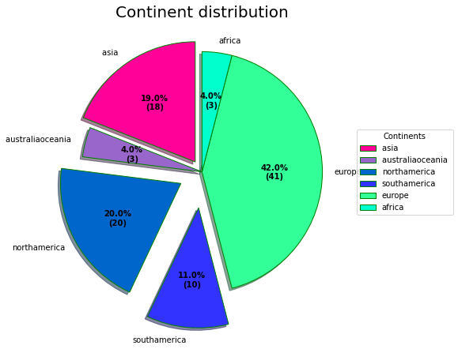

Figure 3 - Continental distribution of suicides

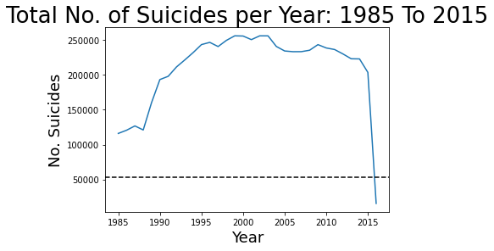

Figure 4 – Suicide rate between 1985 and 2015

We can see that there is a downward trend here and the global suicide rate has fallen over the years. This is due to increased awareness or funding etc. It's predictable, but that's something that can be explored in greater depth later on.

We can then use a bar chart to show the average number of suicides per 100,000 population per year by continent. This time a new data frame is created, grouped by continent. This data frame is then represented below:

Interestingly, we can see that Europe is the continent with the highest suicide rate, followed by North America. Although this figure helps us understand some data, it does not show the change of continents over time.

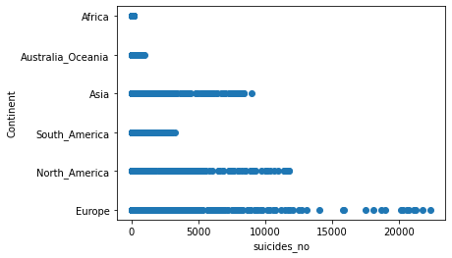

Figure 5 – Numerical distribution of continental suicides

##### Exploratory Data Analysis (EDA)

Exploratory data analysis (EDA) is used by data scientists to analyze and investigate data sets and summarize their main characteristics, often employing data visualization methods. It helps determine how best to manipulate data sources to get the answers you need, making it easier for data scientists to discover patterns, spot anomalies, test a hypothesis, or check assumptions [10].

##### 4.2.1 Suicide Charts and Forecasts of Countries

The number and rates of suicide-related deaths change over time, as social, economic and environmental factors affect the risk of suicide. The number of deaths by suicide increased steadily in the first half of the 20th century, with the ups and downs in suicide numbers corresponding to major world events. However, since the 1950s, the number of deaths by suicide has increased more rapidly over time, in part due to population growth.

Before we move on to continent-based studies of suicide, let's examine the suicide prediction data of some countries. First of all, we will examine the suicidal tendencies of Turkey, Greece, Belgium and Bulgaria countries in the Europe continent and the suicide data in the coming years.

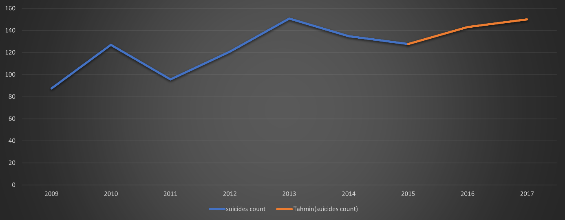

Figure 6 – Turkey's Suicide Prediction Chart

Although suicide progresses in a fluctuating manner in Turkey, it continues to increase in the last 5 years. The economic situation and general weakness, the increase in depression and anxiety diseases of more and more people have led to an increase in the suicide rate in Turkey. According to the Turkish Statistical Institute TUIK, the most common reason for committing suicide was domestic conflicts. For men, the main reason is financial difficulties.

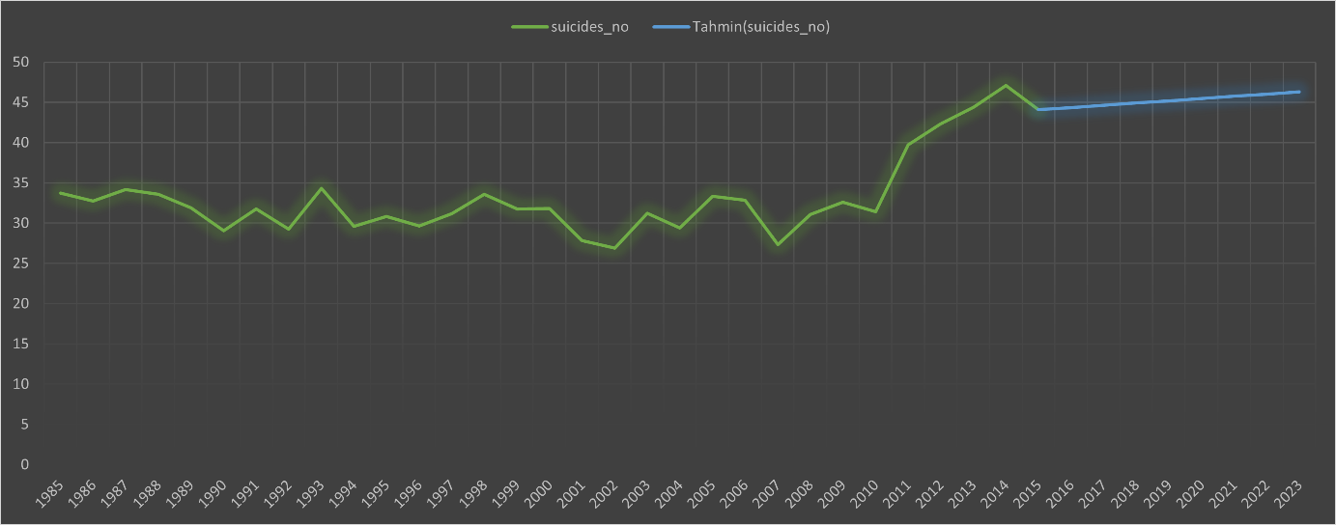

Figure 7 – Greece’ Suicide Prediction Chart

While Greece is one of the rare countries that managed to keep suicide cases at a certain level, there was a serious increase in suicide cases with the economic crisis. It has been recorded that the most important reason for people to commit suicide is unemployment and financial difficulties. In the estimated 8-year suicide data, it is predicted that it will continue to rise with a stable line and a slight acceleration. Suicide policies and social life that started to improve can be shown as the reason for this.

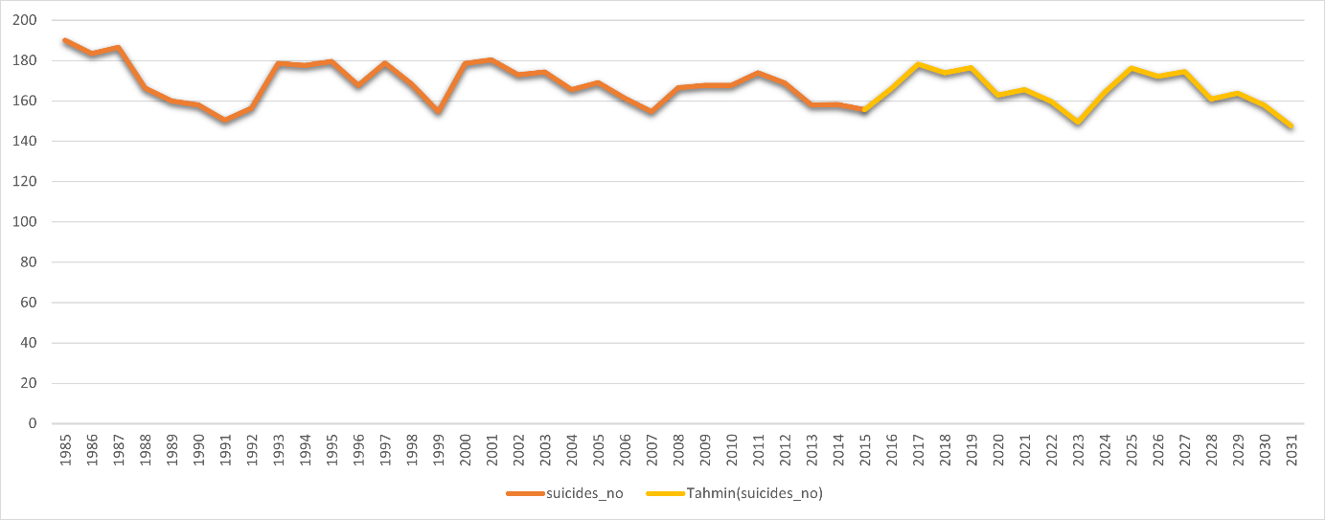

Figure 8 – Belgium’s Suicide Prediction Chart

Belgium has one of the highest suicide death rates in Western Europe. The biggest factor causing this situation is the immigration of Belgium. It is estimated that the suicide rate is directly proportional to the number of emigrations to the coat of arms. The risk of suicide increases with the formation of migration. Although the estimated suicide cases change from time to time, it is observed that they remain above the general average. We can say that the decreasing trend in recent years is due to the immigration policy followed and the awareness brought to the understanding of the risk and protective factors of suicidal behavior.

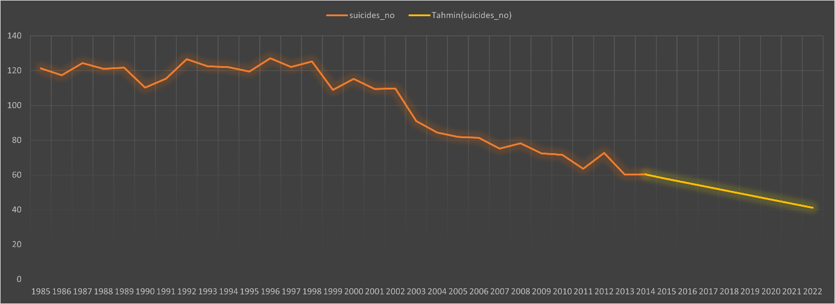

Figure 9 – Bulgaria’s Suicide Prediction Chart

Bulgaria is a European country that quickly managed to drop its suicide data. As a result of the estimations, we predict that the suicide rate will decrease with a serious decrease. Suicide cases in Bulgaria were generally determined to be psychological reasons, and with the right strategy, it succeeded in minimizing suicide.

As the second continent countries, we will examine the suicidal tendencies of Brazil, Canada, Cuba in the South and North America continents and the suicide data in the coming years.

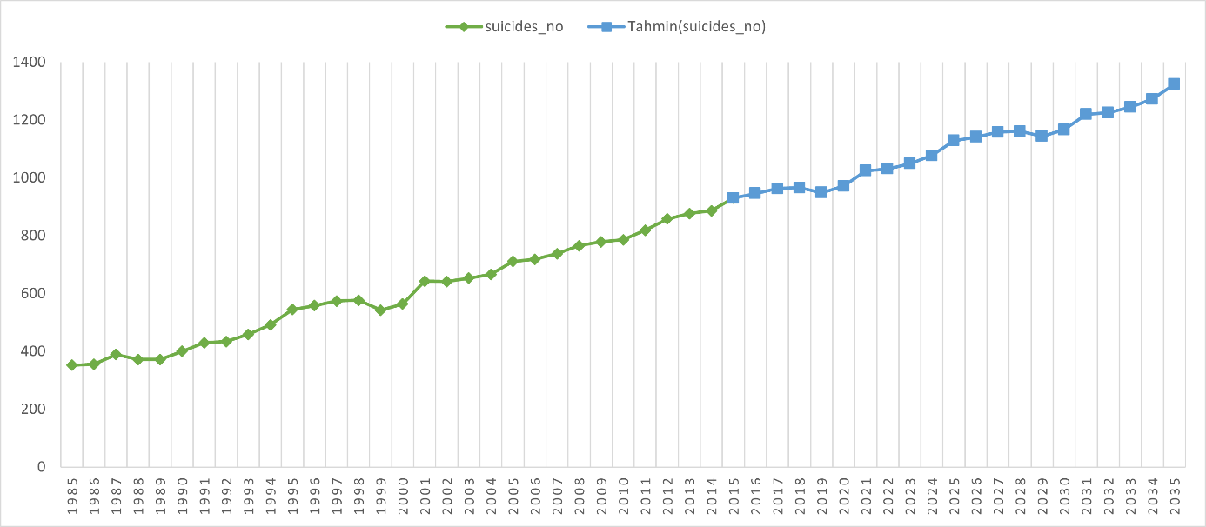

Figure 10 – Brazil’s Suicide Prediction Chart

Brazil is a country with high suicide rates, when we look at the general data, we can see that there is an increasing trend. What we see from our estimation data is that the suicidal tendency will increase. It is predicted that a high rate of suicide cases are under the influence of alcohol or drugs, and the suicidality data will increase due to the rapid increase in susceptibility to these substances. In addition, fluctuations and gaps in income inequality are increasing the gap between suicide rates.

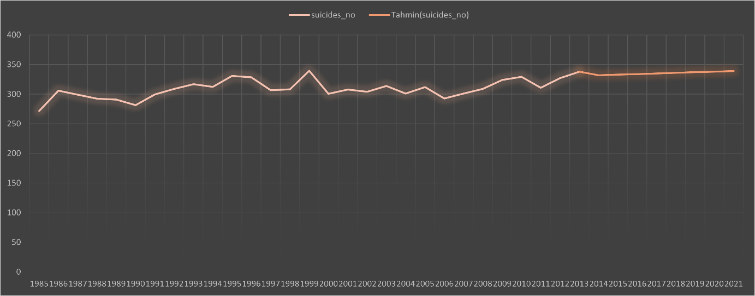

Figure 11 – Canada’s Suicide Prediction Chart

Before I started my project, I thought suicide data in Canada would be pretty low. But my data results showed the opposite. Suicide is among the leading causes of death in Canada, especially among men. Research also shows that members of the LGBTQ community are more likely to consider or attempt suicide. Psychological distress, depression, alcohol and drug use have contributed to this alarming increase in suicide among certain Indigenous communities. Addiction and depression are among the most common risk factors for suicide.

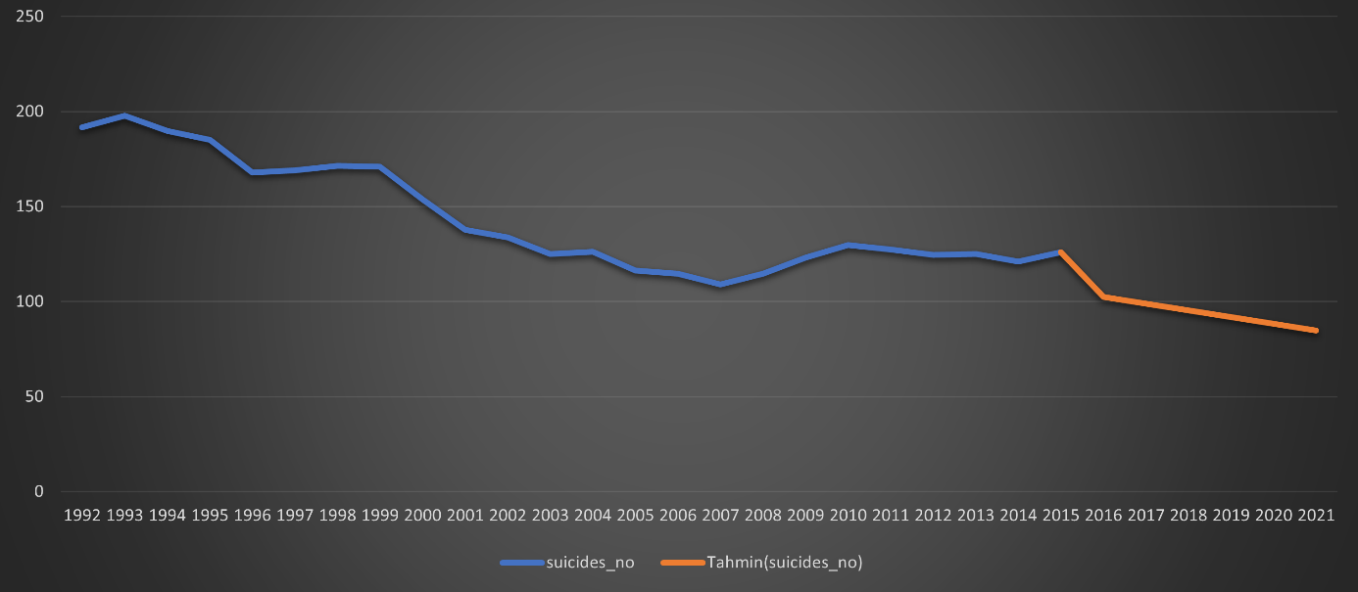

Figure 12 – Cuba’s Suicide Prediction Chart

Suicide has been declining rapidly in Cuba over the past 30 years, and our estimates suggest that it is. For nearly three decades, suicide death rates have almost halved and are still slightly higher than overall rates in North America. We see a country that has been brought under control thanks to the anti-suicide policies.

As a third continent country, we will examine the suicidal tendencies of Australia and the suicide data in the coming years.

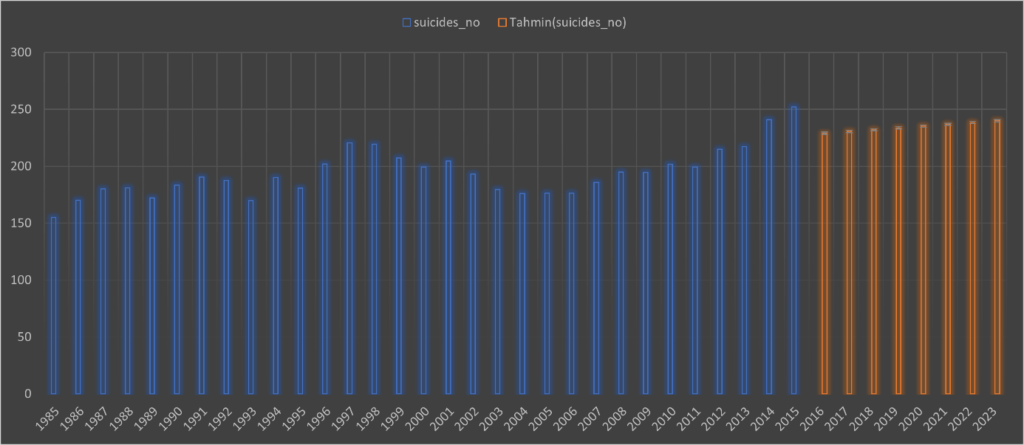

Figure 13 – Australia’s Suicide Prediction Chart

Australia is one of the countries receiving immigration, and when we look at the suicide rates in the last 10 years, I saw that the number of immigrant suicides is almost twice that of domestic suicides. Understanding how social factors affect suicide risk is important to better inform strategies to reduce suicide in Australia and can help plan more effective evidence-based prevention and intervention programs.

##### 4.2.2 Who is more suicidal: Youth, Adults, or Old?

Adults certainly seem to be suicidal more, but what does that mean? According to the data, we have no information to answer. But I guess it's a common age for depression and the like**.** As a result of my socio-economic analysis for this age group, we encounter the main reasons why the 35-54 age group is closer to suicide, such as unemployment, being responsible, and family life. People in this age group should be closely scrutinized and suicide rates should be carefully monitored.

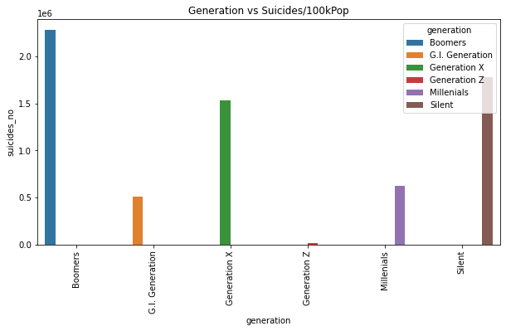

Figure 14 - Suicide rates by generation groups

##### 4.2.3 Suicide Rates of Age Range by Continents

Suicide is one of the leading causes of death in the young and middle-aged.

In the graph here, we see the suicide rates broken down by age groups. These rates are determined as the number of suicide deaths per 100,000 people in a given demographic. Globally, we see the highest suicide rates at 35-54, with the second highest suicide group being 24-35 years old. In fact, while suicides are increasing rapidly among the 24-54 age group globally, the mortality rate for those over middle age follows a standard pattern.

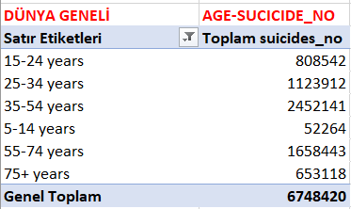

Figure 15-Suicide per Age/Suicide_No

Asia, 35-54 age range suicide rate is highly compared to other age ranges. It is followed by the 55-74 years old and with a nonlinear, linear graph, the suicide rate stays stab. This chart can give us information about death and age ranges in the Asia continent. The high rate of middle-aged deaths in the Asia continent may be due to sociological pressure and unemployment.

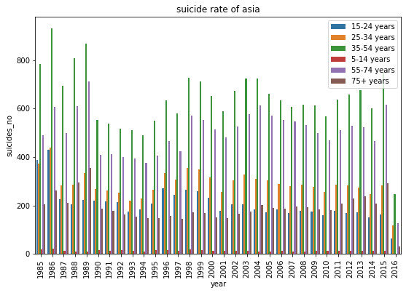 Figure 16- Bar Graph showing the number of suicides of people in different age groups-Asia

We have seen in our data that North America is the continent with the highest suicide rate after Europe. The fact that the suicide rate is high and the 35-74 age group is more prone to suicide reinforces this situation. The fact that the 55-74 age group is the 2nd in suicide is an issue that should be carefully monitored. Despite being a more comfortable group socio-economically, suicide rates are too high to be ignored and continue to rise.

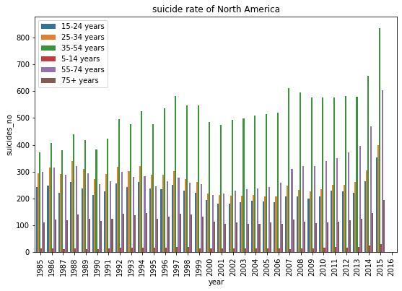

Figure 17 – Bar Graph showing the number of suicides of people in different age groups-North America

Australia Oceania can say it is the continent with the lowest suicide rate compared to other continents. In the last 10 years, suicide rates have reached the highest level in the 35-54 year old. The rise in the suicide rate in the last 10 years, with a serious leap, is an issue that needs to be examined. On the other hand, we see that the 55-74 age group is seriously prone to suicide. It is an age group that should be taken into consideration and examined due to various reasons as well as the declining level of welfare may cause this

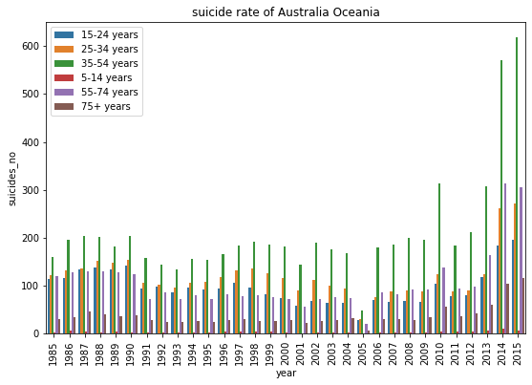

Figure 18– Bar Graph showing the number of suicides of people in different age groups-Australia Oceania

We see that Europe, the continent where the most suicides occur in the world, is well above the world standard in 35-54 middle age group suicides. This age group, which had its peak in terms of suicide between 1989 and 1996, continues to decline non-linearly. One of the most important reasons for this decline is the implementation and follow-up of suicide policies led by WHO.

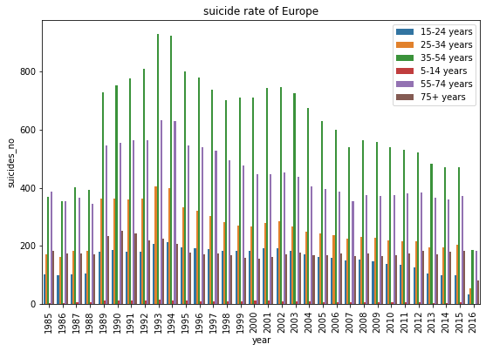

Figure 19 - Bar Graph showing the number of suicides of people in different age groups-Europe

##### Relationship Between Sex and Age Range and Suicide

Let's examine the suicide data by continent, by male and female. Before I start my continent-based analysis, I would like to say that I have not observed that globally, men commit suicide more and that the male suicide rate is almost twice the female suicide rate. Although women attempt suicide at a higher rate, they are more likely to use less lethal methods.

We see that men commit suicide more than women in all age ranges. Men often refuse to seek help after they are more depressed than women. Causes such as the pressures brought by the traditional male-dominated society, economic troubles and unemployment are the main reasons that cause men to get depressed more easily and commit suicide.

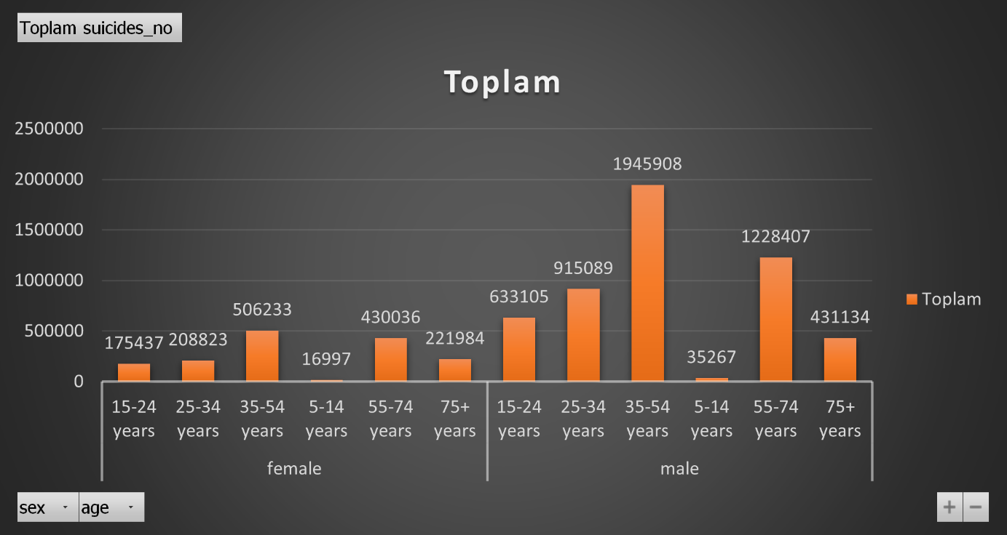

Figure 20 – Relationship between suicide by gender and age groups

Nort-America, surprisingly, the suicide data are not messy at all. however, male suicide rates seem to be considerably higher than female suicide rates. In this case, female suicides between the ages of 15-24 draw attention when compared with other continents. It would be more beneficial for countries to include other features in the table and make a detailed analysis.

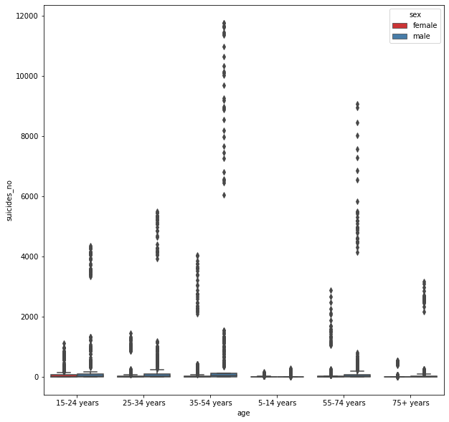

Figure 21 - Suicide rate by gender and age groups-North America

The gender-suicide gap is generally highest on the Europe continent. Rapid economic fluctuations prevented men from fully meeting their families' needs, which in turn prevented them from fulfilling traditional gender roles. Combined, these factors may explain the gender gap. Suicide continues to be high in men, with around 8 in 10 (77 percent) deaths by suicide in Europe being attributed to men and about 31 percent between the ages of 35 and 60. Male gender roles tend to emphasize higher levels of power, independence, risk-taking behavior, economic status, and individuality. This gender role often prevents men from seeking help for suicidal feelings and depression.

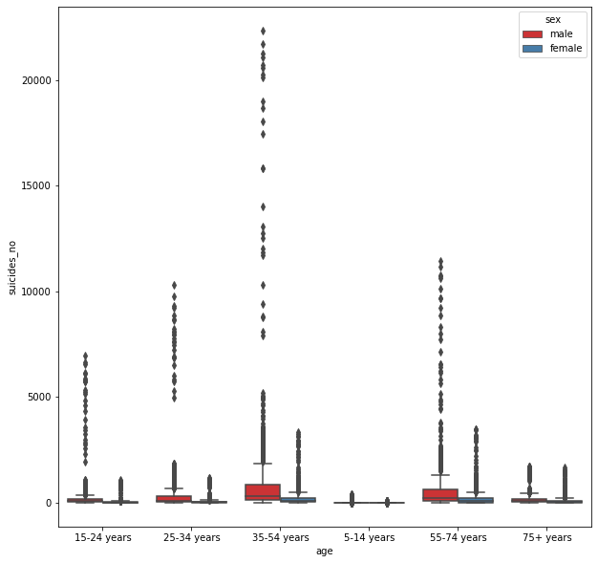

Figure 22- Suicide rate by gender and age groups-Europe

South America, there is less dispersal than other continents. However, I find that suicide is quite high in the 35-54 age group and male suicide is again 4 times that of women. Then comes the 55-74 age range.

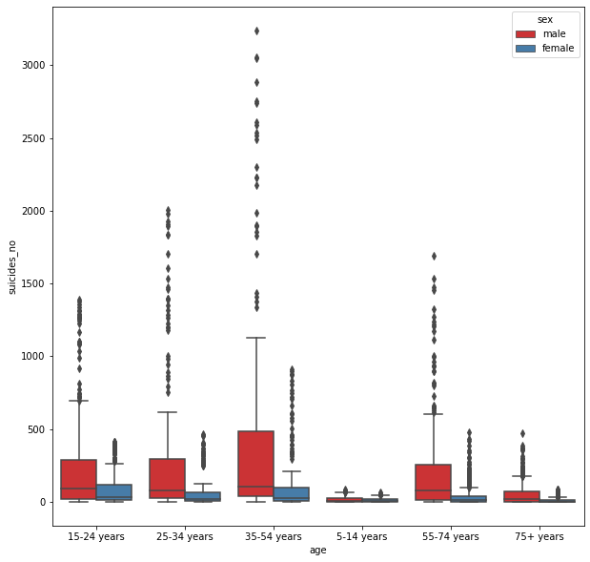

Figure 23 - Suicide rate by gender and age groups-South America

The scarcity of suicide data in the Africa continent may be due to the lack of information flow and the lack of adequate awareness. Due to the higher male workforce, male suicide rates are lower in Africa than in other continents. However, improving living conditions and creating suitable areas before necessary suicide prevention policies may be the most important suicide prevention policy for this continent.

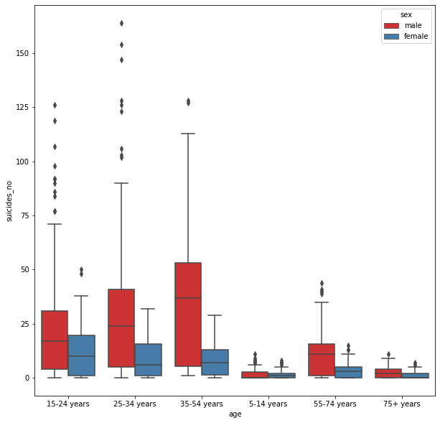

Figure 24 - Suicide rate by gender and age groups-Africa

The fact that male suicide rates are high at all ages in Australia Oceania is a result that needs to be examined. As a matter of fact, although they have higher economic and living conditions compared to other continents, we see that the rate of male suicide is quite high in the 35-54 age group due to reasons such as depression.

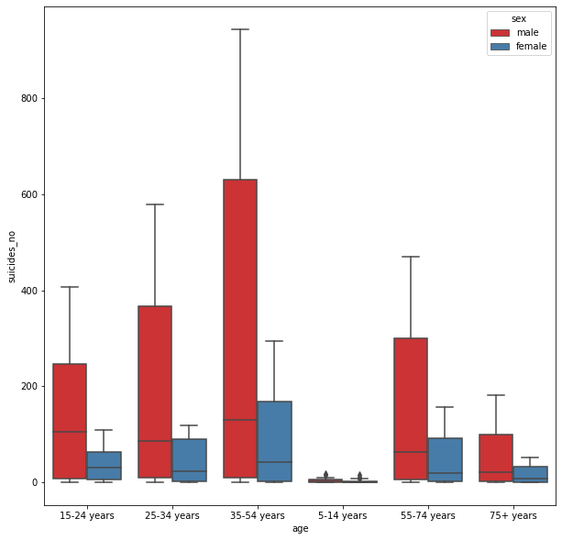

Figure 25 - Suicide rate by gender and age groups-Australia Oceania

When there is an economic downturn resulting in increased unemployment, there tends to be an associated increase in suicide, usually 18-24 months after the crisis. A 2015 study found that for every 1% increase in unemployment, there was a 0.79% increase in the suicide rate. When we look at the continent-based suicide rates, we see that the highest suicide rate in the 15-24 age group is in Europe, the highest suicide rate in the 25-34 age group is in North America, and the 35-54 age group is again in Europe. In fact, in line with these data, we can establish the diagnosis of suicidality in countries with colder climates and more sunlight. When suicide is mentioned, two age groups worldwide come to mind: 15-29 years old and 30-49 years old. On the other hand, the group with the highest suicide rate globally is 70 years and older. This rate is increasing. Especially in developed countries, factors such as the prolongation of the average life expectancy, the weakening of social ties, the decline of the welfare state and the worsening of retirement conditions increase the suicide rate of the metin, küçük resim, vektör grafikler içeren bir resim

Açıklama otomatik olarak oluşturulduelderly. In short, suicide has to do with age.

Figure 26 - The effect of gender and age on suicide rates

In our data analysis, with a clear difference, it has been determined that males are more suicidal in all age ranges. It has become an issue that needs to be investigated and prevented due to its sub-reasons. Depression and financial reasons may underlie the suicidal tendency of the young and middle age group of 25-74. Then let's continue to extract meaningful data with our analysis of countries' GDP.

##### 4.2.5 Does GDP Per Capita Have an Effect on Suicide?

Concentrating on the problem of whether the increase in the GDP of the countries reduces suicide will cause me to obtain important findings in my analysis.

As seen in the chart below;

We can see from this graph that suicides are higher in poor countries. Suicide decreases as income increases, but tends to increase again at some point (about 20k). Before I start my analysis, I can see that this pre-output GDP factor will not be related to suicide.

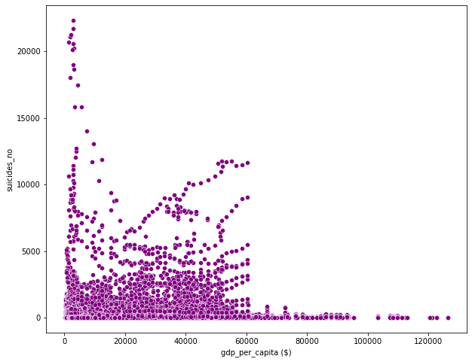 Figure 27 - Suicide rates of countries with different GDP in the world

Now let's take a look at the correlation of each column. The values I used to help interpret the correlation coefficients are as follows;

Interpretation of the correlation coefficient (r);

* If r<0.2, very weak
* eak correlationcorrelation or no correlation
* between 0.2-0.4 w
* Moderate correlation between 0.4-0.6
* High correlation between 0.6-0.8
* If it is 0.8>, it is interpreted that there is a very high correlation.

We can see from the Correlation Heatmap that the number of suicides is clearly related to population. What I didn't expect is that the number of suicides has less interaction with GDP per capita. Before I made this correlation, I thought the suicide rate would be high. I expected higher GDP to be less suicidal. What came out didn't fit my theory. There is a weak correlation between GDP per capita and Suicide per 100,000. This means that when the suicide rate increases, GDP per capita also decreases.

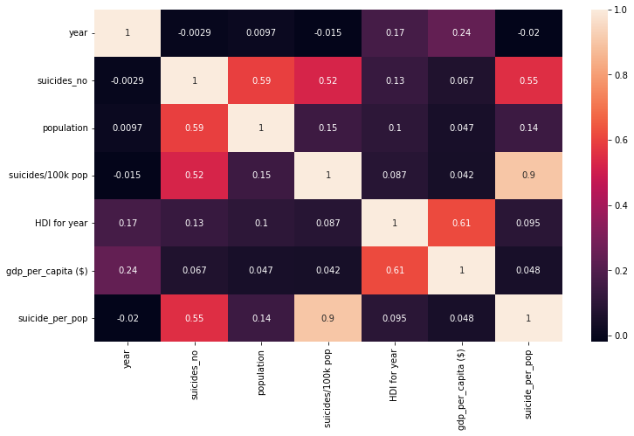

Figure 28- The correlation between different columns.

I have done GDP_PER CAPITA and suicidality correlation using Pearson method. Using the Pearson method in this data frame, we can say that there is a positive correlation between GdpPerCapita($) and Suicides_no 0.042, that is, there is a positive correlation between the two. However, we see that they are not very related to each other. We concluded that there is a positive weak correlation.

##### 4.2.6 Generation and Suicide

Here is some information regarding the generations.

• Greatest Generation (G.I. Generation): 1901-1927

• Silent Generation: 1928-1945

• Boomers: 1946 – 1964

• Generation X: 1965 – 1980

• Millennials (Generation Y): 1981 – 1996

• Generation Z: 1997 – 2010

Then I plotted the average suicide rate for each generation. We see that the Generation of Boomers has the highest suicide rate. Boomers are people born between 1946 and 1964. Next comes the Silent Generation, followed by Generation X. Therefore, we see that older people have a higher risk of suicide.



Figure 29- Suicide rates by generation

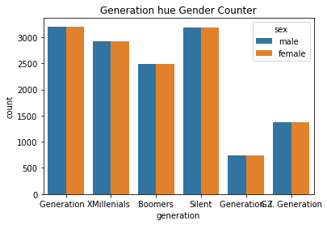

Figure 30 - The suicidal relationship between generation and gender

Suicide numbers are higher in the Silents generation for both sexes (Female and Male). Since the Silent Generation corresponds to the years 1928-1945, we can actually predict that those born in this generation committed suicide due to war and economic reasons.

Suicide rates are lower for both genders in Generation Z. When I wondered if the generation differences had anything to do with gender, I saw that the Silents generation had a very high suicide rate for both men and women. In Generation x and Millennials that follow him, the suicidal tendency is quite high. I predicted that this situation should be taken seriously and necessary studies should be carried out to reduce suicide rates.

Teen suicides constitute an important public health problem. Young people, and especially adolescents, are by nature a vulnerable group to mental health problems. While suicide in children is relatively rare, suicidal ideation increases significantly throughout adolescence. Although youth suicide rates have dropped slightly in Europe and around the world, it remains the leading cause of death among young people and therefore we must live with this sense of responsibility as a whole society.

### Implementation of Project

##### Overview

We see the change in the number of suicides by country as the most obvious analysis.

While suicide rates were more stable between 1985-1990, they reached a very high peak between 1990-2005. Although the economic crisis developing in the world is one of them, it is necessary to examine this important situation with other data sets.

I would like to state that I have benefited in this direction by visualizing the world's suicide data in my thesis and that I have found answers to the questions I will mention below.

• What is the percentage of men and women suicide globally?

• What is the distribution of suicides among the different age groups?

• What is the suicide rates among the different generations?

• Concentrating on Looking at Suicides trends overs years questions, I visualized and interpreted my Suicide data with the help of various libraries in Python. I shared the codes of this project, which I aim to contribute to the World Suicide Rates, on my Github link.

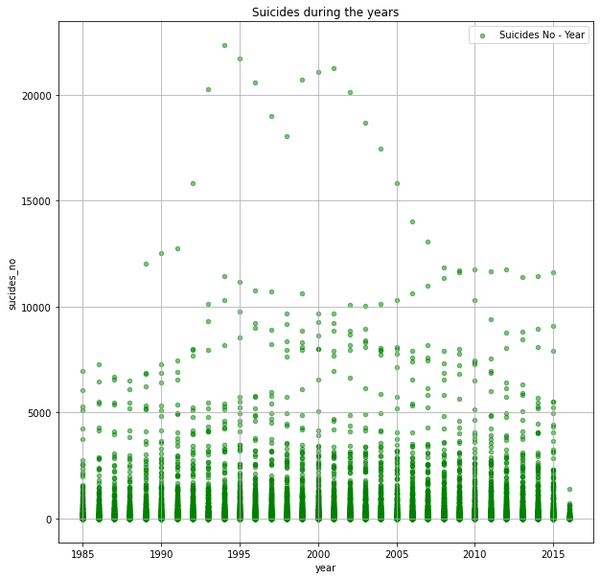

Figure 31 – World Suicide Rates

data.plot(kind='scatter',x='year',y='suicides_no',alpha=0.5,color='green',

figsize=(10,10),

grid=True,label='Suicides No - Year')

plt.xlabel('year')

plt.ylabel('sucides_no')

plt.legend()

plt.title('Suicides during the years')

plt.show()

Figure 32 – World Suicide Rates Code

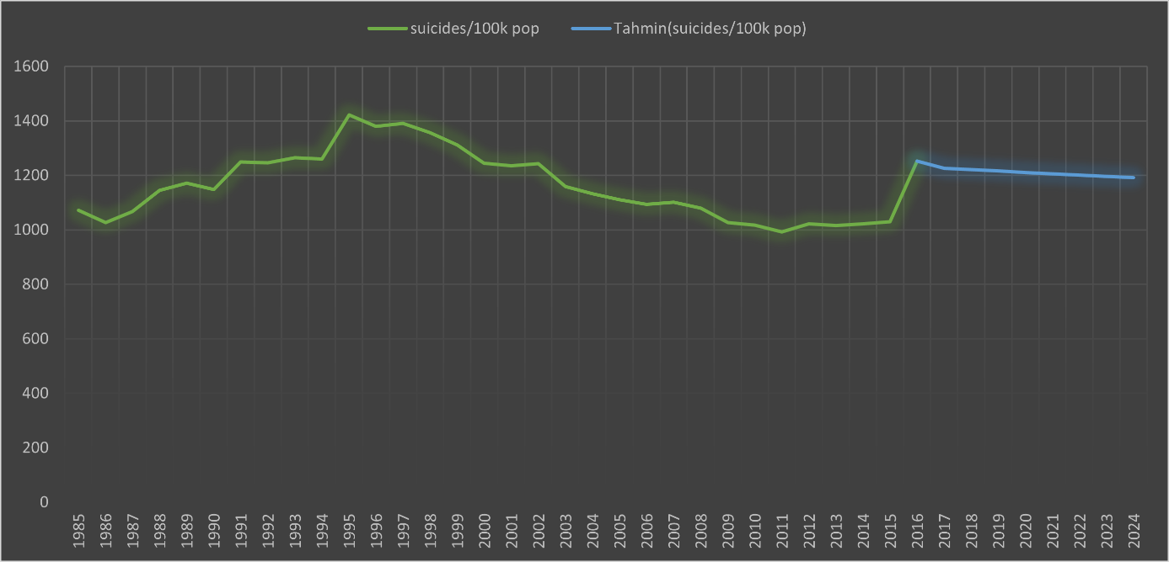

Figure 33 – Forecasting Suicide per Year Rate

The idea of suicide, which is a serious problem all over the world, is becoming an issue that needs more attention day by day. While the incidence of suicide has started to decrease with various policies and sanctions, it is seen that it has started to rise again with economic fluctuations, immigration and the prevalence of firearms. In our estimation data, it seems that suicide is stably under control. Even if a serious decrease is not expected, country-based updated suicide policies and new WHO-supported applications seem to work.

### Results and Discussion

First, it asks what causes suicides globally, which is our problem, and who affects them.

The scope of my project has covered many countries over the last thirty years. I worked with the Kaggle called 'Suicide Rates Overview 1985 - 2016' dataset, as the results of my project were to gather information about what causes suicides around the world.

Data are organized by country, male or female, and age, generation and continents, and the number of suicides per year.

I analyzed various analytical elements to see correlations between age, gender, year and GDP to get the most unbiased analysis possible.

Source of dataset [**https://www.kaggle.com/russellyates88/suicide-rates-overview-1985-to-2016**](https://www.kaggle.com/russellyates88/suicide-rates-overview-1985-to-2016)Also My Project all steps are in my GitHub repository

[**https://github.com/zeynepdigdeaydi/Examining-and-Analyzing-World-Suicide-Cases-from-Different-Perspectives-**](https://github.com/zeynepdigdeaydi/Examining-and-Analyzing-World-Suicide-Cases-from-Different-Perspectives-) available.

##### Results

The distribution of suicide rates according to age ranges shows us that the general prejudice about suicide is mostly in the young group. The distribution says that neither teenagers nor young adults are in the most common age range for suicide rates. Middle adults showed the highest suicide rate; children and young people are even higher than their rates combined.

Young people and middle-aged people, for example school, life situation, group of friends, etc. They must make decisions about important concrete aspects in life, such as They must also address the new challenges associated with constructing their own identities and gaining increased independence and responsibility. Meanwhile, they themselves are exposed to ongoing and changing psychological and physical processes. They may find it difficult at times to overcome these difficulties. Young and middle-aged should identify the different types of factors that are clearly associated with an increased risk of suicide, which is very important for the rapidly increasing risk of suicide.

Why was the middle adult population at such a high risk of suicide between 1985 and 2016?

Wars, scientific development, technology, industry, social changes, economic crises and/or many possible situations in our environment can further affect our actions towards ourselves.

It shows that the high variability in male suicide rates has increased over the years compared to females, and sometimes even doubled.

Suicide is one of the leading causes of death among adults worldwide. The data show worrying differences in suicide for the different sexes. It is clear that men are more suicidal than women. While rates do not differ much in the mid to late 1980s, there is a big difference in male suicide after 1990, but not so much in female suicide. The data also allow us to see that population size is a great indicator and one of the reasons for suicide rates in general.

People living in countries with a large population have a higher rate of suicide attempts and suicide than countries with a low population. The data also doesn't seem to matter in annual GDP suicide rates. Although I thought before starting the project that a high GDP ratio would result in less suicide, I found a low correlation between GDP and suicide, both in multiple correlations and in my other visualization analyzes. We may think that someone has committed suicide because of financial problems, puberty problems, or gender, and we can make many guesses. But the reality doesn't even seem close to these predictions. People commit suicide and we can't generalize that. We should not try to shape it. Suicide is not like any harmful or negative action because ending someone's life is about more than statistical data.

More people die from suicide than from war and murder. Many suicides occur instinctively during times of crisis, when the ability to cope with life stresses such as financial problems is impaired. Suicide rates are also high among vulnerable groups subject to discrimination, such as refugees and migrants. This increase in global suicide rates should be interpreted with caution. Despite the wide and appropriate use of rates, the information they report alone can be misleading, especially when comparing data between countries or regions with significant demographic differences. As recommended by WHO, one should not overlook other components that are more dependent on people's social and physical environment.

According to this approach, other actions to prevent suicide include:

* Control of the presence of toxic substances and drugs
* Limited access to weapons
* Media reporting about suicide

In any case, suicide remains a major public health problem, although it is preventable.

##### Discussion

I assumed that suicide rates would be higher for younger individuals, men, and those in low-GDP countries. First of all, when we look at our data set by dividing it into age groups (5-14, 15-24, 25-34, 35-54, 55-74, 75+), it is seen that suicide rates are increasing gradually. There are more suicides in the 35-54 age group in all groups and in all genders. we saw this. Then I determined that the 24-34 age range followed it. These observations directly contradict our hypothesis that we think younger individuals would have higher rates of suicide.

Finally, I wanted to see if there was a relationship between country GDP and suicide rates, and I did my analysis in that direction. I found that there is a positive but weak relationship between the country's GDP and suicide rates, but we can't get a clear connection with the data we have. Overall in our project, we discovered through graphs, charts and tables that higher rates of suicide come from men and middle-aged people.

### Conclusion

Therefore, our conclusion from this project is that there are more cases in men than in women. Although I searched for a link between GDP and suicide, I couldn't get a clear idea. We found a positive but weak correlation between GDP and the suicide rate. When I made a link between the generation and suicide data, I concluded that the Boomers generation was the bird most suicidal. In the light of these data, I think that those born this year mostly commit suicide due to economic and war reasons. People between the ages of 35-54 commit suicide more than other age groups. Suicide is a method that does not crust over at any age and period. In the light of these data, I can predict that countries should make more observations and cooperate with WHO in the fight against suicide.

### References

[1] “Suicide.” *World Health Organization*, World Health Organization, https://www.who.int/news-room/fact-sheets/detail/suicide.

[2] Bilsen, Johan. “Suicide and Youth: Risk Factors.” *Frontiers in Psychiatry*, Frontiers Media S.A., 30 Oct. 2018, https://www.ncbi.nlm.nih.gov/pmc/articles/PMC6218408/.

[3] Demir, Mustafa. “Who Commits Suicide Most? Suicide by Gender and Age.” *State University of New York at Plattsburgh, USA*.

[4] Phillips, Julie A, et al. “Understanding Recent Changes in Suicide Rates among the Middle-Aged: Period or Cohort Effects?” *Public Health Reports (Washington, D.C. : 1974)*, Association of Schools of Public Health, 2010, https://www.ncbi.nlm.nih.gov/pmc/articles/PMC2925004/.

[5] World Health Organization. “Preventing Suicide A Global Imperative.” *WHO Library Cataloguing-in-Publication Data*, 2014.

[6] “Why More Men than Women Die by Suicide.” *BBC Future*, BBC, https://www.bbc.com/future/article/20190313-why-more-men-kill-themselves-than-women.

[7] Mishara, Brian L., and David N. Weisstub. “The Legal Status of Suicide: A Global Review.” *International Journal of Law and Psychiatry*, Pergamon, 13 Sept. 2015, https://www.sciencedirect.com/science/article/abs/pii/S0160252715001429.

[8] “Global, Regional, and National Age-Sex-Specific Mortality for 282 Causes of Death in 195 Countries and Territories, 1980–2017: A Systematic Analysis for the Global Burden of Disease Study 2017.” *Institute for Health Metrics and Evaluation*, 12 Nov. 2020, http://www.healthdata.org/research-article/global-regional-and-national-age-sex-specific-mortality-282-causes-death-195.

[9] Ali Emre Þevik, Halil Özcan, Emin Uysal. “İntihar Girişimlerinin İncelenmesi: RiskFaktörleri Ve Takip.”

[10] By: IBM Cloud Education. “What Is Exploratory Data Analysis?” *IBM*, https://www.ibm.com/cloud/learn/exploratory-data-analysis.

[11] Szamil. “Who Suicide Statistics.” *Kaggle*, 29 Aug. 2018, [www.kaggle.com/szamil/who-suicide-statistics](http://www.kaggle.com/szamil/who-suicide-statistics).

[12] Ritchie, Hannah, et al. “Suicide.” *Our World in Data*, 15 June 2015, ourworldindata.org/suicide#data-sources.

[13] *Define_me*, www.thelancet.com/journals/lancet/article/PIIS0140-6736(18)32203-7/fulltext.

[14] “Applying Data Mining Techniques on ACADAMIC Institutional System Using Weka.” *International Journal of Recent Trends in Engineering and Research*, 2018, pp. 86–88., doi:10.23883/ijrter.conf.20171201.016.jkrgn.

[15] “Veri Görselleştirme Nedir?” *Retmon*, www.retmon.com/blog/veri-gorsellestirme-nedir.

[16] Keller, Jared. “The U.S. Suicide Rate Is at Its Highest in a Half-Century.” *Pacific Standard*, Pacific Standard, 4 Dec. 2018, psmag.com/news/the-suicide-rate-is-at-its-highest-in-a-half-century.

[17] DOĞRUL, Aslı. “ALKOL KULLANIMI VE İNTİHAR OLASILIĞININ STRESLE BAŞEDEBİLME YÖNTEMLERİ İLE İLİŞKİSİNİN İNCELENMESİ.” *İSTANBUL ÜNİVERSİTESİ ADLİ TIP ENSTİTÜSÜ*, 2010.

[18] “Who: Preventing Suicide: A Resource for Media Professional.” *Suicidologi*, vol. 8, no. 1, 2015, doi:10.5617/suicidologi.1847.